Wednesday 12th October

Back In Action:
The Alexander Technique as used in the GB Coxless Four Athens 2004
Liz Dodgson & Caroline Chisholm

About the speakers: Caroline Chisholm has used the Alexander Technique for 30 years and has taught it for 20. Since 2000, she has worked with many of the GB squad, including Steve Williams, Ed Coode and Alex Partridge. Elizabeth Dodgson is an Alexander Technique teacher based in Chiswick. She has a particular interest in bringing the benefits of the Technique to sports people. She has had success in helping people to swim in a way that is comfortable and does not put a strain on the neck and shoulders and teaches runners how to run in way that reduces risks of injury. She also offers ski/Alexander instruction in Tignes,France and works with Tideway-based oarspeople.

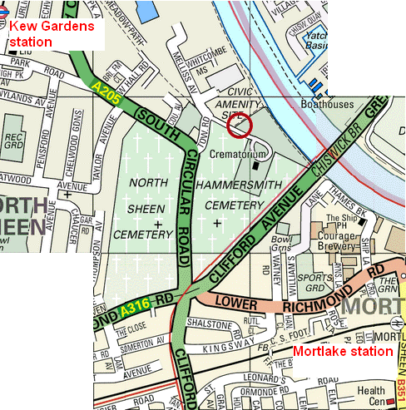
Time: 7:30pm – 9pm
Cost: £3 for ARA members (card required), £5 for others

Venue: Putney Town RC Kew Meadows Path, Kew
10-15 mins walk from Kew Gardens or Mortlake stations. Ample car parking

