Friday 5 November
Pre race coxes’ talk
Stan Collingwood, Bill Mitchell and Rachel Quarrell

About the speakers: Stan Collingwood is a member of the Thames Region Umpires Commission & the national Umpires’ Working Party, Stan has been asked by the TRRC to work on the Salvage Association risk assessment. Bill Mitchell is an active coach and umpire who also sits on the national Umpires’ Working Party, and is a member of the HoR4s race committee. Rachel Quarrell is the editor of the Rowing Service and rowing correspondent for The Daily Telegraph. A highly experienced cox and coach, Rachel is based in Oxford where she works with OURCs on coxing issues.

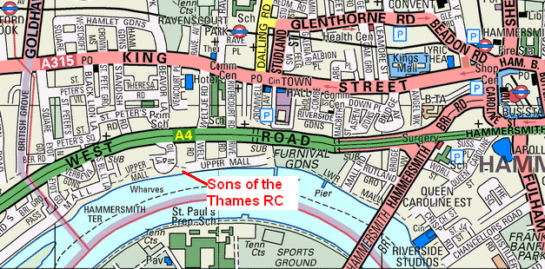

Time: 7:30pm – 9pm Cost: FREE
Venue: Sons of the Thames RC Linden House, Upper Mall
Hammersmith, W6 9TA. 500 yards upstream of Hammersmith Bridge. Nearest tubes:
Ravenscourt Park (District line) or Hammersmith (Piccadilly and Hammersmith & City line). By car: access is via Oil Mill Lane, a turning off the westbound A4 between the Hammersmith and Hogarth roundabouts. Look for the BP petrol station and turn left immediately after its forecourt. Linden House is at the end of the lane.

