Wednesday 17th November
Physiology
Craig Williams
Craig will discuss basic and rowing physiology, then highlight the training approaches to improving these areas and also give some take home practical advice on recovery, which was a focus for the GB rowing squad pre Athens.
About the speaker: Craig is a physiologist working for the English Institute of Sport, based at Bisham Abbey. He combines this with finishing his PhD at UCC in Chichester - this follows a Masters and a Degree in exercise and physiology also from UCC. Over the course of the last few years Craig has carried out physical assessments on all types of sportspeople from sailors to boxers to football league referees. At the EIS, Craig works with the GB rowers. He describes himself as an indoor rowing “fanatic”.

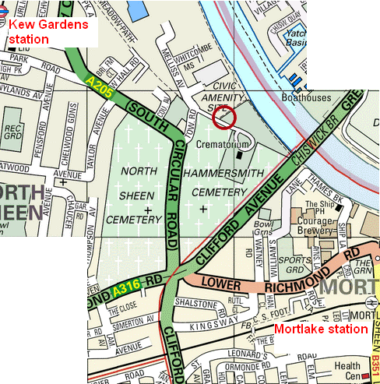
Time: 7:30pm – 9pm
Cost: £2 for ARA members (card required), £4 for others

Venue: Putney Town RC Kew Meadows Path, Kew
10-15 mins walk from Kew Gardens or Mortlake stations. Ample car parking

