Sunday 14th November

Sharing The Water
Stuart Ward and Colin Brown

The session will be split into two parts:
1) What water safety training does and will the ARA provide?
2) What water safety training do we - the clubs and the region - need?
An essential session for Club Chairmen, Club Water Safety Advisers or anyone who has responsibility for the safety training of others e.g. coaches, captains etc.
About the speakers: Stuart Ward is Chairman of the National Water Safety Committee and Hon. Water Safety Adviser to the ARA. Colin Brown is the ARA Education & Training Officer.
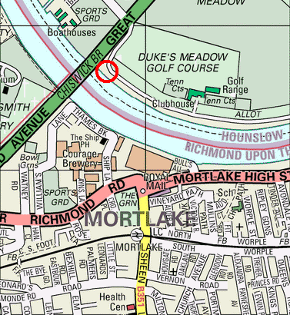
Time: noon

Cost: FREE

Venue: Tideway Scullers School
Dan Mason Drive
Chertsey Rd
London W4 2SH
10-15 mins walk from Mortlake station. Ample car parking.

