SOUTH EAST REGiONAL ROWING COUNCIL
PRESENTS:
Tuesday, 12 October, 2004

“My Olympic Experience”
by Debbie Flood
Silver Medallist
Womens 4x, Athens Olympic Games

Debbie will present her story of the training, the pain and the glory of her crew leading up to the Athens Olympic Games

Come join us for an exciting evening!

7:30 pm to 9:00pm
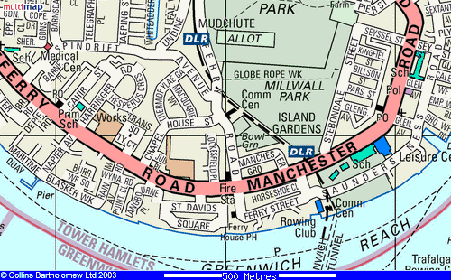
Venue: Poplar Blackwall & District Rowing Club
Cost: £2.00 for ARA members; £3.00 non members

