
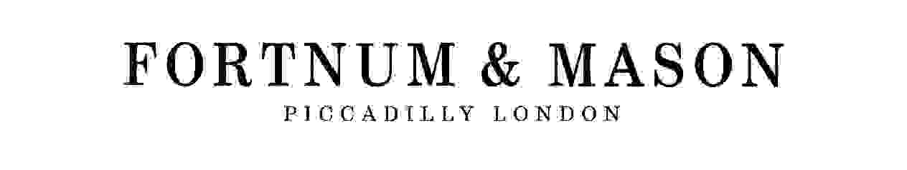


The Fortnum & Mason
Sue Ryder Care Luncheon

18 October 2004
St James’s Restaurant

12 noon Drinks Reception
Followed by Luncheon

Guest speaker
Tickets £45

For further information and ticket purchase call the Fundraising Department on 020 7400 0448
Sue Ryder Care, 114-118 Southampton Row, London WC1B 5AA Reg. Charity No. 1052076

