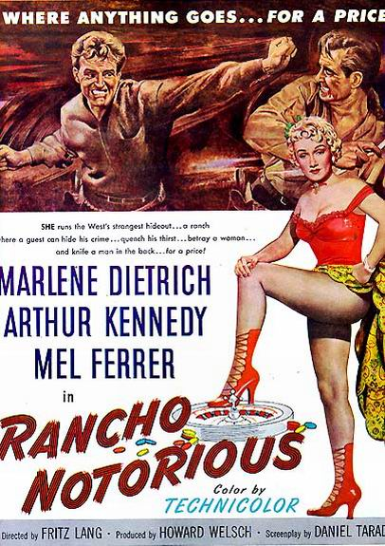
T
H
A
M
E
S

R
O
W
I
N
G

C
L
U
B

W
H
O
R
R

Party
2005

The rodeo begins 5th March 2005 from 7pm
£3 for Annie Oakleys, Calamity Janes, Pocahontas, bucking broncos, lonesome cowpokes, desperados, city slickers, rawhide rowers, gay cowboys, goldrush girls, red necks, square dancers, sheep stealers & cattle rustlers… £5 for everyone else.
WHY NOT COME & LASSOO A NOVICE? DRINK TEQUILA? LICK SALT OFF OUR COX?

