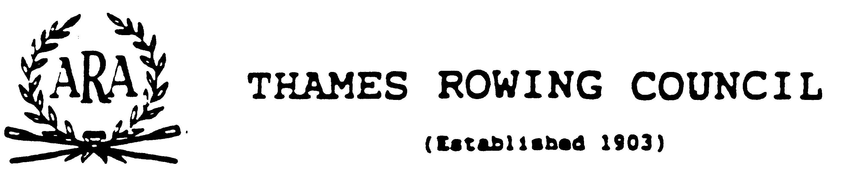

Thames Regional Umpires’ Commission
Date Address for any reply
26 September 2004 45 Sterne Street
E Mail London
john_e_robson@hotmail.com W12 8AB
Telephone
020 8743 8596 (Home) 07876 230278 (Work/Mobile)

Training as an Umpire in the Thames Region
These notes outline what is involved in training as an Umpire in the Thames Region.
The ARA rules of racing require that every regatta uses licensed umpires for certain duties. The Thames Regional Umpires’ Commission is responsible for the training and regulation of Umpires in the region, which covers the area from East London through to Oxford. At present there are just over 120 umpires in the region.

What do umpires do at a Regatta?
Typical duties at a regatta would include:
Starter | Some larger regattas have an umpire purely responsible for starting crews. Normally in the Thames Region, the Race Umpire starts the crews.
Aligner | Typically found at larger or bank umpired events. The aligner determines whether or not the bows are level. If not the umpire instructs that the boats be pushed forward or backwards. When the crews are level, the umpire signals to the starter. The aligner may call a false start.
Race Umpire | In the Thames Region, most races are umpired from launches. The race umpire typically starts the crews. During the race the umpire tries to ensure that the crews do not clash, leave the course or take an unfair advantage e.g. by cutting a corner.
Bank Umpire | Only a few regattas in the region are bank umpired. The umpire is responsible for only part of the course.
Co-ordinating Umpire | In a bank umpired course, one umpire is put in overall charge. The umpire listens to radio messages from the bank umpires.
Finish Judge | At least one Judge must be a licensed umpire and the Judge determines the finishing order of the crews.
Control Commissioner | Again, at least one Control Commissioner must be an umpire and is responsible for spot checking the composition of crews (names and eligibility for the event) as well as spot safety checks in the boating area.
On a typical day, an umpire would carry out more than one type of duty e.g. a mix of launch umpiring and judging.
Some umpires sit on head and regatta committees and help to organise them. The Rules of racing require some involvement to ensure that the planning takes account of the rules of racing.

Who can train as an Umpire?
There are no formal criteria for what constitutes a suitable candidate. Candidates have almost always been actively involved in the sport as a competitor, coach, club officer or event organiser. It is not necessary to have rowed personally.
The age range of the current Umpires in the region is 25 – 69. Many people train as Umpires when they cease to compete in open events or retire due to injury. Some Umpires continue to compete as Veterans. Candidates must be nominated by a Club, Regatta etc.
Importantly, an umpire needs to be able to deal firmly but fairly with competitors.
The ARA requires that licensed umpires are registered members of the ARA.

What is involved in training?
The training process is geared to the rowing season. We are currently recruiting for 2005.
The typical process is as follows.
December/January | Initial meeting. A chance for Commission Members to meet you and to explain the training process. The 2005 date has yet to be fixed.
February/March | Written examination on the rules of racing. Candidates must pass this examination to proceed with the rest of the program.  To be an Umpire you need to have to be able to demonstrate a very good understanding of the Rules of Racing published in the ARA Almanac. The exam takes approximately an hour. The 2005 date has yet to be fixed.
March | Attend two training heads and hopefully work with an experienced Umpire in order to find out how Umpires are now involved in Heads.
March/April | Attend one of the two annual Umpire Seminars to understand what the topical issues are.
April – Late June | Attendance at selected Training Regattas. There are typically up to 10 possible dates. Candidates are expected to get a mix of experience between tideway and non-tideway and bank umpired versus boat umpired. Candidates are expected to go to at least 5 events. Where possible later in the season, candidates are given hands on practise under the supervision of experienced umpires.
Early July | Tabletop examination. Candidates are tested on the practical application of the Rules by Umpiring simulated races on a tabletop.
Late Summer | Qualified!

Further training?
Once you qualify and receive your licence, you can umpire any race in England. There is an optional Multi Lane endorsement, which indicates that you have passed a multi lane examination. The more lanes that are involved, the more the race umpire has to consider. For example, there may be steering problems simultaneously in two places, which is the more important?
Typically the people who are nominated for multi lane training have at least three years experience and umpire regularly to a high standard. The opening of a second multi lane course in the region is imminent.
The final qualification available is the FISA qualification. This permits the umpire to officiate at events held under FISA rules. Only umpires with a multi lane endorsement are considered and FISA requires that candidates must be under the age of 50.

Renewal of Umpire Licences
The normal validity of a Licence is 3 years. Renewal is contingent upon the retention of ARA membership, Umpiring in at least two – three events per year and periodic attendance at the Annual Umpire seminars.

Any questions
If you have any questions please feel free to contact me, John Robson, the Honorary Secretary of the Region.

